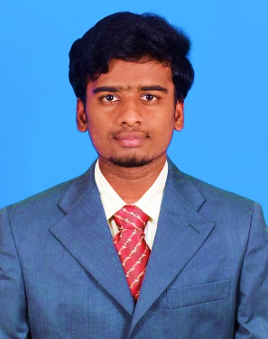

Nihethan Eswaran

Junior-Java Developer & Frontend Web Developer

 [Email/Nihethan Eswaran](mailto:nihethane@gamil.com)

 [LinkedIn/Nihethan Eswaran](https://linkedin.com/in/nihethan-eswaran-a24a492a8)

 [GitHub/Nihethan Eswaran](https://github.com/nihethan)

 9042744116

**PROFILE SUMMARY**

Motivated Java Developer with foundational skills in (Basic) Java, DSA , SQL,HTML,CSS AND JAVA SCRIPT. As a fresher, I am eager to learn and contribute to innovative projects, bringing a strong understanding of core Java concepts and database management.

**EDUCATION**



**SSLC**

Star Matriculation Higher Secondary School, Karur with **79.2%** (2018-2019)

**HSC**

Star Matriculation Higher Secondary School, Karur with **83.16%** (2020-2021)

**UG**

Nandha college of Technology, Perundurai, Erode.

B. Tech-Information Technology

**CGPA-7.7** (2021-2025)

**SOFT SKILLS**

• Platform expertise

• Content creation

• Analytics

• Communication

• Problem Solving

**TECHNICAL SKILLS**

* JAVA(Intermediate)
* C and C++(Basic)
* HTML and CSS(Basic)
* Java Script (Basic)

**PROJECT**

**Calculator GUI by Java**

Develop a Java-based calculator with a user-friendly GUI using Swing, supporting basic and advanced arithmetic operations, with a focus on modular code for easy maintenance and future enhancements.

**Text to speech web page**

• HTML: Provides the structure and layout of the web page, organizing the content and interface elements.

• CSS: Styles the page, making it visually appealing with design elements like fonts, colours, and layouts.

•JavaScript: Handles the functionality, enabling the text-to-speech feature by interacting with web APIs to convert text into spoken words.

•Integration: Combines HTML, CSS, and JavaScript to create a seamless user experience for converting text into speech on a web page.

**CERTIFICATION**

* **NPTEL**: Programming in JAVA with **ELITE**
* [HackerRank Certificate](https://lnkd.in/gkwNV8-2)

**HOBBIES**

* Practicing in Online Websites
* Hearing Songs
* Playing Games (Simulator)
* Traveling in Public Transport